Group 19 A7 Progress Report

Game project: 1024

Our project will be similar to the game 2048 but will be called 1024.

The game will implement:

1. A 2D game that is implemented via Processing within the sketch group_yourgroupnumber_assignment6.pde (or .pyde). This game will include the following elements:
2. At least three rules of play that dictate how the player decides to interact with the system:

1) The user swipes the blocks up, down, left, or right

2) When the user moves the blocks into each other, the numbers change according to the two blocks combined.

3) When the blocks are swiped into each other, they combine into one block.

1. Five keyboard and/or mouse inputs:

Up: moves the blocks up

Down: moves the blocks down

Left: moves the blocks left

Right: moves the blocks right

Mouse click: clicks buttons in the UI

1. A visual display for the player to understand game state.

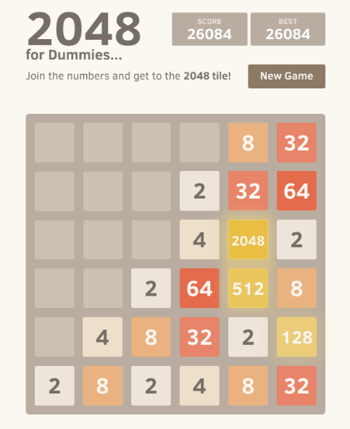Screen will look similar to the image to the left.

1. A GUI interface for scoring or other important player information.

Score will be displayed on the top of the screen.

1. Win or lose conditions that present the player with a victory or defeat screen after the conditions are met

At the end of the game, once the user reaches 1024, the win screen will be displayed with their score.

**Breakdown of classes/splitting of work:**

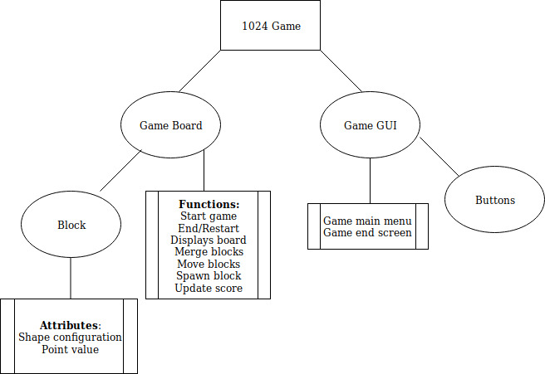

There will be four classes:   
 **Block**

This class creates the blocks and assigns them their numerical value.

**Game Board**

This class is the bulk of the functionality—it consists of the gameplay functionality.

**Game GUI**

This class consists of the UI surrounding the game board, including the main menu, end screen, and scoreboard.

**Buttons**

This class consists of the button elements that the user will be interacting with.

The contributions will not be split by classes. Each individual will be contributing evenly to each class. This is subject to change depending on future project needs.